Development of E-commerce Website for Maker’s IT

Practicum Report Title

A Practicum Report Submitted By
Md. Amiruzzaman Bin Ali
ID# 16103394

In Partial Fulfillment of the Requirements for the Award of
Bachelor of Computer Science and Engineering



Department of Computer Science and Engineering
College of Engineering and Technology
IUBAT – International University of Business Agriculture and Technology
Fall 2018
Development of E-Commerce Website for Makers IT

Md. Amiruzzaman Bin Ali
A practicum report submitted in partial fulfillment of the requirements for the degree of
Bachelor of Computer Science and Engineering (BCSE)

The practicum has been examined and approved,
______________________________
Prof Dr Md Abdul Haque
Chair and Professor
Dept. of Computer Science and Engineering
IUBAT – International University of Business
Agriculture and Technology

______________________________
Dr Utpal Kanti Das
Coordinator and Professor
Dept. of Computer Science and Engineering
IUBAT – International University of Business
Agriculture and Technology

______________________________
M.M. Rakibul Hasan
Lecturer
Dept. of Computer Science and Engineering
IUBAT – International University of Business
Agriculture and Technology
Department of Computer Science and Engineering
College of Engineering and Technology
IUBAT – International University of Business Agriculture and Technology
Fall 2018

Abstract

“Development of E-Commerce Website for Maker’s IT.” has been developed to override the problems in practicing manual system. The ultimate goal is to reduce the hardship and eliminate the manual system. This software is developed and designed for the particular need of the organizations so they can use daily operations like customer can view all the products, the can see any products using category wise they can see the details of the product, they can buy the products. In this system only authorized members will be able to handle the information’s about the products and the user information. This system provides efficient way to managing the organization. This system is developed using core php & Laravel framework which are very popular and MySQLI database. For the front-end development HTML, CSS, JAVASCRIPT, JQUERY & BOOTSTRAP4 are used. This System is very user friendly and can give up-to-date information’s about the products as well as the storing the information about the product.

Letter of Transmittal
10th December, 2018
Chairman, Practicum and Placement Board
Collage of Engineering and Technology-CEAT
IUBAT-International University of Business Agriculture & Technology 4Embankment Drive Road, Sector-10
Uttara Model Town Dhaka-1230, Bangladesh
Subject: Letter of Transmittal
Sir,
With due respect, I would like to approach you that it is a great opportunity as well as immense pleasure for me to submit this report titled “Development of E-Commerce Website for Maker’s IT.” For the fulfillment of my practicum course. I have tried my best to make the project successful on time. After completing my project I have written this report which describe what I developed in last three months and detail analysis of my project.
It was undoubtedly a great opportunity for me to work on this project to actualize my theoretical knowledge and has an enormous exposure with the corporate culture of my renowned IT firm. Now I am looking forward your kind appraisal regarding this practicum report.
I shall remain deeply grateful to you if you kindly go through this report and evaluate my performance.
Sincerely
--------------------------
Md. Amiruzzaman Bin Ali
ID# 16103394
Program: BCSE
Enclosure: Project Report

Student’s Declaration

I am Md. Amiruzzaman bin Ali, student of IUBAT- International University of Business Agriculture & Technology, declaring that this project paper on the stated topic has only been prepared for the fulfilment of CSE-490(Practicum), as partial fulfilment of “Bachelor of Computer Science & Engineering.”

It has not been prepared for any other purpose, reward or presentation.

………………………..
Md. Amiruzzaman Bin Ali
ID-16103394
Program-BCSE

Acknowledgements

In the name of Allah who is the most merciful and most grateful.
It’s our pleasure to take this occasion to thank a few people, who have assisted, encouraged directly and support us throughout our practicum program.
Firstly, I want to thank my parents, who have endowed their support and encouragement to attain this exquisite event of my life.
We are very appreciate to Dr. Abdur Rab(Vice Chancellor of IUBAT) and Dr. Utpal Kanti Das(Course Coordinator of CSE) for their direction and sustain throughout the semester. I would also like to thank all of the faculties of IUBAT for their support and wisdom.
Especially I am thankful to my practicum supervisor M.M. Rakibul Hasan (CEAT- Collage of Engineering & Technology) for helping me to prepare a report on “Development of E-Commerce Website for Maker’s IT.” and his continuous guidance. His instruction and guidance of extreme help for me. I am also thankful for all the times I am consulted with him and he answered with utmost patience and perseverance.
I will always grateful to Managing Director and all Members of “Makers IT” for their support throughout the whole project.
I also like to thank all oy our friends for their valuable suggestions and comments.

Dedication (if any)

To my Parents it’s impossible to thank you adequately for everything you have done.

Supervisor’s Certification

This is to certify that Practicum report on “Development of E-commerce website for Maker’s IT.” has been carried out by Md. Amiruzzaman Bin Ali bearing ID:16103394 of IUBAT-International University of Business Agriculture and Technology as a partial fulfillment of the requirement of practicum defense course. The report has been successfully prepared under my guidance. To the best of my knowledge and as per his declaration, no parts of this report has been submitted anywhere for any degree, diploma or certificate.
Now he is permitted to submit his report. I wish him all success in their future endeavors.

Practicum Supervisor

-----------------------------------
M.M. Rakibul Hasan
Faculty, Department of
Computer Science and Engineering
IUBAT- International University of Business Agriculture and Technology

Department Certification
03 December , 2018
Md. Amiruzzaman Bin Ali
ID: 16103394
Program: BCSE
IUBAT- International University of Business Agriculture and Technology
4, Embankment Drive Road, Sector 10
Uttara Model Town, Dhaka -1230, Bangladesh.

Subject: Letter of Authorization.
Dear Md. Amiruzzaman Bin Ali
You will be happy to know that I have received your project proposal on “Development of E-Commerce website for Maker’s IT.” under my continue internship. Based on your proposal you will have to submit it as soon as possible. I hope you will successfully complete the project on time. After successful completion of the project, you are requested to write a report based on the project.
For any kind of needs don’t hesitate to contact with me.

--------------------------------------
Dr. Utpal Kanti Das
Practicum Coordinator Supervisor and Faculty,
Department of Computer Science & Engineering

Table of Contents

Development of E-Commerce Website for Maker’s IT I
Abstract III
Letter of Transmittal IV
Student’s Declaration V
Acknowledgements VI
Supervisor’s Certification IX
Department Certification X
Table of Contents V
List of Figures VI
List of Tables (if any) VII
Chapter 1 Introduction 1
1.1 Communications 2
1.2 Basic elements of communication System 2
1.2.1 Sending and Receiving devices 2
1.2.2 Communication Channel 2
1.3 Communication Channel 2
1.4 Creating Table 3
1.5 Creating Example 3
1.6 How to cite references 4
References 5

List of Figures

Prepare the list of figures by using ‘Insert Table’ options in MS word. Use font-size 12, Spacing (before => 2 and after => 2.) and Line-space 1.5.

Example:
Figure 1.1 Computer Networks……………………………………………………………....  Figure 2.1 Star topology……………………………………………………………………... | 5  11

List of Tables (if any)

Prepare the list of tables by using ‘Insert Table’ options in MS word. Use font-size 12, Spacing (before => 2 and after => 2.) and Line-space 1.5.
Table I. Network equipments………………………………………………………….........  Table II. Comparisons of LAN, MAN, and WAN………………………………………..... | 5  11

Chapter 1

Introduction

Project Overview
“Development of E-Commerce Website for Maker’s IT ” is safe and very much secure, which is reliable, available, and easily accessible to users. There will be two types of users with authorization power for login the system.
System admin will handle the all information in the system. Admin have the permission to access all the product information. Customer can view all the product and their related information. The ultimate objective of the system is to provide facility to the owner and the customer for management of a company. Security of this system is very high and the possibility of doing wrong in the calculation is low. The proposed system will involve computerized Apply system, database storage, retrieval (using defined functions), evaluation, agreement, modifications and decision making supports which will make all processes involving the system much faster and easier for the users.

Objective
The objective of developing such a computerized system is to reduce the paper work and safe of time in employee management. There by increasing the efficiency and decreasing the work load.
The system provides user the information about employee, leave and related information. The system must provide the flexibility of generating the required documents on screen as well as on printer when required.

Broad Objectives
The broad objective of this project is to use my educational knowledge and experience acquired from IUBAT in the real life working environment by developing an “Development of E-Commerce website for Maker’s IT.” of Maker’s IT that has been assigned to me. This report is generated to describe the processes and works done in different levels of E-Commerce system. In this report I have described every part of the development segments with proper illustrations that can be used by the organization.

Specific Objectives
- To make an automated system that can handle update of every product information including product details, product availability, product quantity and product selling price.
- To make a system that will be very user friendly.
- To manage organizational information.
- To reduce time wastage that occurred in manual system.

Scope of this Project
This software have the capacity to deal with the product information, their availability and information backup. All approved individual can utilize the software with their username, password. Using this software package authority can keep track of their product. Software should have the feature of storing every product information without any inconvenience.

Benefits of the System
- Admin will add product
- Admin will add product category wise.
- Admin will give descriptions of the product.
- Admin can see every orders from customers.
- Admin can manage inventory.
- Customer can view the product.
- Customer can view the details of the product.
- Customer can add to cart as much quantity as he/she may needs.
- Customer can remove any product from the cart.
- Customer will get invoice.
- System can easily store information.
- System can easily provide information to the customer.
- It will have less time consuming than the manual system.
- Customer can easily access to the site.
- Customer can easily view all the products and order as much quantity as he/she may needs.
- The system will insure the Security.

Methodology
The Development process on “Development of E-Commerce website for Maker’s IT.” through “Rapid Application Development(RAD) Model “ will complete following the structure described later on Software Analysis and Design.

Data Source
There are two sorts of data sources, from where I utilized the data to develop the software project and they are:
- Primary data are gathered from the organizations. The organization’s practical experience, observation and face to face interview with our own web developers helped me gathering the primary data.
- Secondary Data are gathered by studying diverse articles, blogs and websites.

Software Process Model
For developing a system or project I have to follow a process model. To find out the problem and select the appropriate solution I have followed the basic process model, Which is RAD Process Model.
Rapid Application development is a form of Agile software development methodology unlike waterfall methods RAD emphasize working software and user feed back over strict planning and requirement recording.
RAD is ales talk and more action.
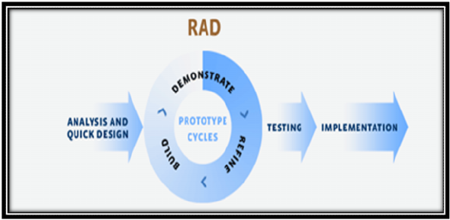
Fig 1.1: RAD Model

Why RAD Model?
While the waterfall model is very slow phasing in recent years. The RAD process models provides a number of benefits, particularly for larger system that require the stages and deadlines. Some points are given below:
- Customers and Owners Satisfaction.
- In RAD Process Model more interaction maintained within developing and testing team in this process model.
- Customer can change or add requirements any stage.
- It concentrate on every process with expert team members.

Feasibility Study
The aims of any feasibility study are to find out whether a system is worth implementing and if can be implemented within the existing budget and schedule. The input of the feasibility study is a set of preliminary requirements. There are many different types of feasibility study, some of the most important list are given below.
- Technical feasibility
- Economic feasibility
- Operational feasibility

Technical Feasibility
Technical feasibility concern about the hardware capability, reliability as well as availability also the skills of the team. This study looks at the hardware and software available to perform for the proposed system.

Requirements for System operation:
- Processor: Dual core or higher.
- Ram: 2GB or higher.
- Hard Disk Space: 750GB or higher.
- System: Windows/7/8/10
- Technology: Server/Local server/MYSQLI
- Software: Any Modern updated browser(Opera/Firefox/Chrome).

Economic Feasibility
Economic feasibility determines whether the system is economically feasible or not. It also determines what extent a new system is cost effective. We consider whether the company will be able to pay for redesigning and the system will be cost effective or not. The proposed system is within our budget for development.

Operational feasibility
Operational feasibility determines whether the proposed system can solve the problems as well as concerns about user acceptance, management support and requirements entities. It will help to track down all the information.

Chapter 2
The Organization

  - Organizational Overview

Maker’s IT Limited is an Electronics, web and Android solutions provider at its core with the highly qualified developers having experience of more than 3 years in various and complex designs. Other than our core service like web design and development. Maker’s IT has satisfied the clients with the services like Electronics Product, Mobile app Design and development, Software and Mobile Testing, SEO and Social Media Designing & Development. We are customer centric and divert our efforts to act as a one stop solution provider in the area of IT. In every area of our operations we work hard in understanding the Client’s requirement and providing the solution.

  - Our Services
- Making Electronics Product.
- Web Application.
- Android Application.
- Software Development.

    - Making Electronics Product

Electronics product has always been a most selling and growing because of its usability and demand. Having a different kind of electronics product could be the game changing market tool. So, to meet the clients demand we develop different kinds of customized electronics products.

    - Web-Design

At Maker’s IT, we focus on creating search engine friendly, aesthetically appealing and interactive website designs. It is a known fact that to build a strong web presence and to secure the countless marketing opportunities available on the internet, a good website is imperative, thus triggering a race for Website Design while designing and developing your website, our professionals keep in mind key factors like easy-navigation, overall consistency and content quality, stipulated timeframes and budget. Higher for the company is to be ranked on the Search Engine result pages.

    - Android Application
In recent years, application market is exploding the demand for mobile apps is growing because of its portability and efficiency. Having an app for any business or promotion it can be a game changing marketing tool to drive traffic and revenue. So, to meet clients demand we develop Android Application.

2.2.4 Software Development
At Maker’s IT we offer fully integrated software development and technical support solutions. Maker’s IT is well-experienced custom software Development Company and software outsourcing company. We have great expertise in the development of custom software applications due to our professional team efforts in performing the work according to the need of our offshore clients. We strive to focus on the customer and deliver solutions designed around their requirements rather than focusing on a specific technology and expecting the customer to adapt to the technology and platform of our choice. We use to fulfill specific needs of our clients as per their convenience for their business.
  - Location

House: Apt-12/C, Tropical Aladdin Tower, Plot- 32/C
Road- 02
Sector- 03
Uttara Model Town
Dhaka, Bangladesh 1230
Website: www.makersorb.com

  - Vision

- To build a trusted IT Companies in Bangladesh
- To be the largest Electronics & Software Companies in Bangladesh
- To be the largest online retailer
- To be the best choice for people when they like to Apps Development
- To be the largest SEO (search engine optimization) Marketing Company in Bangladesh
- To be the largest IT company in World.

  - Mission

Produce excellent service in the field of IT Service, Software Development, Website Design & Development, Apps Development, SEO (Search Engine Optimization), SMM (Social Media Marketing), Online Advertisement, e-database systems and banking home and abroad, E-commerce and Consultancy with maximum effort driven toward customer satisfaction.
Our Mission at a glance:
- To achieve maximum customer satisfaction over the entire life cycle of our customer solution via our excellence of products and solutions.
- To consistently enhance our competitiveness and deliver profitable growth.
- To practice highest standards of corporate governance and be a financially sound company.
- To be a partner in nation building and contribute towards Bangladesh economic growth.
- To encourage ideas, talent and value systems and become the customers of choice.
- To earn the trust and confidence of all customers, exceeding their expectations.
- To uphold the guiding principles of trust, integrity and transparency in all aspects of interactions and dealings. Vision to build upon a reputation of being one of the most innovative IT Solution and Service provider. We believe in doing our work in the most efficient way with robust and structured methodology, with gradual evolution from hard-work to smart- work culture, at client’s end also.

  - Organizational Structure
Chief Executive Officer
(CEO)
Director of IT
Director of Marketing
Chief Financial Officer (CFO)
Financial Officer
Marketing Team Leader
Sales Executive
Sales Executive

System Analyst
Programming Team Leader
Software Tester
Programmer #1
Programmer #2
Programmer #3

Software Designer

Figure 2.1: Organizational Structure of Maker’s IT.

Chapter 3
Requirement Engineering

3.1 Requirement Engineering
Requirement engineering refers to the process of defining, documenting and maintaining requirements and to the subfields of systems engineering and software engineering concerned with this process. Designing and building an elegant computer program that solves the wrong problem serves no one’s need. That’s why it is important to understand what the customer wants before we begin to design and build a computer-based system. Requirement engineering encompasses the tasks that lead to an understanding of what the business impact of the software will be, what the customer wants, and how end-users will interact with the software.

3.2 Requirement Analysis

Typically, requirements are presented into two level of detail; user and system requirements,
where user need a high-level statements of the requirements, while system developers need a
more detailed system specification. So, user and system requirements just refer to different level
of detail. In the following task phases the requirement analysis was done.

User requirement 1:
Admin dashboard contains all options for changing the application content from admin dashboard.
System requirement 1.1:
Admin panel will be accessed by admin.
System requirement 1.2:
Admin must login.

User requirement 2 :
Admin will add products.

System requirement 2.1:
Admin must login through his/her valid username and password.
System requirement 2.2:
After login admin get Product option. After clicking the product there will be a drop-down menu option named Add new there admin can add product.
System requirement 2.3:
Admin will add product category wise.
System requirement 2.4:
Admin can give a description of the product.

User requirement 3:
Admin can confirm the order from the customer.
System requirements 3.1:
Admin must login the system.
System requirements 3.2:
After login the system, Admin get a option named Order. Through this option admin can confirm any order.
System requirement 3.3:
Admin can view all the order.
System requirement 3.4:
Admin can see all the pending order.
System requirement 3.5:
Admin can see all the delivered order
System requirement 3.6:
Admin can see all the returned order.
System requirement 3.7:
Admin can see all the cancel order.

User requirement 4:
Admin can handle product information in details.
System requirement 4.1:
Admin must login the system.
System requirement 4.2:
After login the system admin will get a option named product. Through this option admin can update the quantity of the product.
System requirement 4.3:
After login the system admin will get a option named product. Through this option admin can delete the product.

User requirement 5:
Admin can check the status for the order.
System requirement 5.1: Admin must login the system.
System requirement 5.2: Admin will see a dash board on the dashboard admin will get to see all the status for the order .

User requirement 6:
Admin can manage inventory.
System requirement 6.1: After getting feedback from the stuff admin can update the status

User requirement 7:

Admin can add stuff
System requirement 7.1:
Admin must login to the system.
System requirement 7.2:
Admin will see a dashboard. In the dash board there will be a option named stuff. Through this option admin can manage the stuff.
System requirement 7.3:
Admin can add new stuff.
System requirement 7.4:
Admin can see the stuff list.

User requirement 8:

Anybody can order any products
System requirement 8.1:
User need to register a form after submitting the form user can login to the system.
System requirement 8.2:
User can see any product. User can see any products category wise.
System requirement 8.3:
User can view the details of the product.
System requirement 8.4:
User can add to cart products as much quantity as he/she may needs.
System requirement 7.5:
User can remove any product from the cart.
System requirement 7.6:
User will get an invoice.

3.3 Functional Requirements:
Functional requirement specifies a function that a system or system component must be able to
perform. In this software, they are:
- Customer Online order System.
- Customer Order Confirmation.
- Product Details view.
- Add to cart.
- Invoice Generate.
- Admin will see the order.
- Admin can update the product quantity
- Admin can confirm the order.
- After confirming the order Admin can give the status for the order.

3.4 Non-Functional Requirements:
Security requirements:
- System will have a very secure login.
- Password will be invisible.
- Authentication Users.
- Protecting Routes.

Reliability requirements:
- The system should be consistent and should give the desired results.

Efficiency requirements:
- The software should be efficient enough to take less memory of the computer system.
there should not be any performance degradation.

Usability requirements:
- The system should be easily usable by the stuff of the basic learning of computer systems can operate it.

3.5 Use Case Diagram
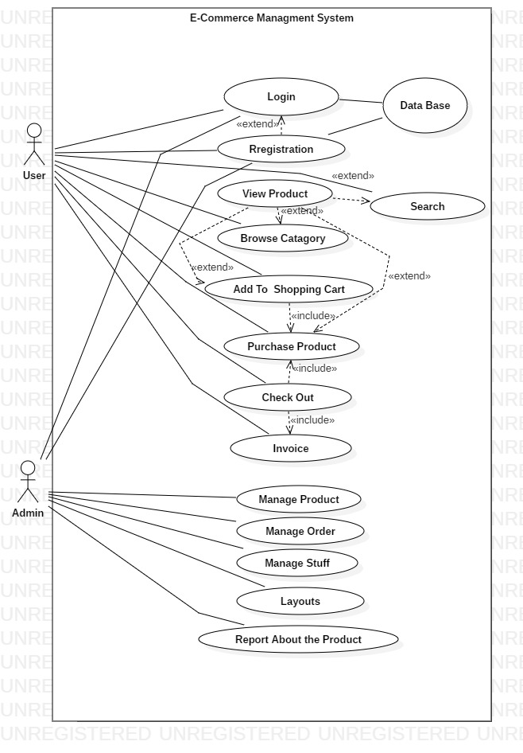

Figure 3.1: Use Case Diagram.

Chapter 4
System Planning

4.1: Function Proposed System:

Login into the System | F1
Customer Registration | F2
View Products | F3
Add To cart Products | F4
Update Products | F5
Delete Products | F6
Checkout Orders | F7
Invoice | F8
Order Status | F9
Add Products | F10
Add Stuffs | F11
Remove Stuffs | F12
Add layouts | F13
Update layouts | F14
Order Information | F15
Generate Report | F16

4.2 Functions Description
- F1 Login into the System:
Input: User Name, Password, Type
Output: Login Successful, Login Failed
- F2 Customer Registration:
Input: First Name , Username,Email,Password,Confirm Password,Mobile1,Mobile2,Address
Output: Success
Use table of the database: tbl_user
- F3 View Products:
Output: Product Category, Product type, Availability,Price,Discount,Specifications.
Use table of the database: tbl_product.
- F4 Add To cart Products:
Input: User id, Product id, Quantity, Product Price,Total Price .
Output: Success
Use table of the database: tbl_cart
- F5 Update Product:
Input: Product Quantity
Output: Success.
Use table of the database: tbl_cart
- F6 Delete Product:
Input: Remove Product
Output: Success.
Use table of the database: tbl_cart
- F7 Checkout Order:
Input: Name,Mobile1,Mobile2,Address,Email
Output: Success.
Use table of the database: tbl_order.
- F8 Invoice:
Output: Ordered Products and Price
Use table of the database: tbl_invoice.
- F9 Order Status:
Output: Purchase Products and their Delivery Status.
Use table of the database: tbl_invoice
- F10 Add Products:
Input: name,Code ,Solditems,Buying Price,Price,Discount,Quantity,Newarrival,catgory,Type,Image1,Image2,Image3,Status,Specifications.
Output: Success.
Use table of the database: tbl_product
- F11 Add Stuffs:
Input:Name,username,phone,email,password,confirmpassword.
Output: Purchase Products and their Delivery Status.
Use table of the database: tbl_admin
- F12 Remove Stuffs:
Input: Remove
Output: Success
Use table of the database: tbl_admin
- F13 Add layouts:
Input: Image1,Image2,Imag3
Output: Success
Use table of the database: tbl_image
- F14 Update layouts:
Input: Image1,Image2,Imag3
Output: Success
Use table of the database: tbl_image
- F15 Order Information:
Output: View Order Details
Use table of the database: tbl_order
- F16 Generation Report:
Output: View Report
Use table of the database: tbl_order

4.3 Project Planning
Before starting any project, it is compulsory to estimate the work to be done, the resources that will be required, the time that will elapse from start to finish and to analyze the project to determine whether it is feasible or not.
The following activities of software project planning that have followed in this project are:
  - Estimation of the software project
  - Task scheduling
  - Personnel requirements
  - Resource requirements
  - Estimation of the software cost
  - Costs benefit analysis

4.4 Function Point Estimation
The task of counting function points should be included as part of the overall project plan. That is, counting function points should be scheduled and planned. The first function point count should be developed to provide sizing used for estimating.

4.5 Function Oriented Metrics
Function point based estimation focuses on information domain values rather that software values. Function points are computed by comparing five information domain characteristics. The information domain values are as follows
Number of external inputs – Each user input that provides distinct application-oriented data to the software is counted inputs should be distinguished from inquires.
Number of external outputs – Each user output that provides application-oriented information to the user is counted.
Number of external inquires – An inquiry defined as an on-line input those results in the generation of some immediate software response in the form of an on-line output. Each distinct inquiry counted.
Number of files – Each logical master file counted.
Numbers of external interfaces – All machine-readable interfaces that used to transmit information to another system counted.
The weights of the domains are fixes, which are provided in appropriate table location. Weights can be divided into three categories according to the functionality of the system. They are simple, average and complex. The total system is a complex system but the part of the total system. Once these data has collected, a complexity value is associated with each count.
To find out the FP count the following formula is used,

FP Count = (((4 * Most Likely) + Optimistic + Pessimistic) / 6) * Weight)
To compute function points (FP), the following relationship is used:

FP = Count Total * [0.65 + 0.01 * Σ (Fi)]
Complexity adjustment factor = [0.65+0.01*Sum of factor values]
FP estimated =count total*Complexity adjustment factor.
Function Point Estimation = Total FP estimated/No. of function point.
The count total is the sum of all FP entries.

- FP count:
Domain | Optimistic | Likely | Pessimistic | Est. Count | Weight | FP Count
Number of External Input | 9 | 4 | 11 | 6.00 | 3 | 18.00
Number of External Output | 20 | 8 | 20 | 12.00 | 4 | 48.00
Number of External Inquiries | 6 | 3 | 6 | 4.00 | 3 | 12.00
Number of Internal Logical Files | 24 | 13 | 20 | 16.00 | 7 | 112.00
Number of External Interface | 15 | 7 | 11 | 9.00 | 5 | 45.00
Count Total: |  |  |  |  |  | 235.00

Figure 4.1: FP Count

- Complexity adjustment value:
Number | Factor | Value
1 | Does the system require reliable backup and recovery? | 2
2 | Are specialized data communications required? | 3
3 | Are there any distributed processing functions? | 0
4 | Is performance critical? | 1
5 | Does the system run in existing operational environment? | 0
6 | Does the system require off-line data entry? | 3
7 | Input transaction over multiple screens | 0
8 | Are the master files updated on-line? | 2
9 | Are the input, output, files or inquiries complex? | 0
10 | Is the internal processing complex? | 0
11 | Is the code designed to be reusable? | 4
12 | Are conversations or installation included in the design? | 0
13 | Is multiple designed for change? | 0
14 | Is the system designed to facilitate change and case? | 4
 | Σ (Fi) | 19
Complexity Adjustment Factor = 0.84

FP Estimated = 197.4

Figure 4.2: Complexity Adjustment Table

4.6 Function Point Estimation
Here FP Estimated = 197.4,where the FP is estimated using the formula:
FP Estimated = Count Total * Complexity Adjustment factor.

Function Point Estimation = Total FP Estimated / No. of function point.
=197.4 / 10 =19.74 man month.
= 20 man month (Approximate).

Time Frame Calculation = 20 / 05
= 4 Months
4.7 Process Based Estimation

In process-based estimation, process is decomposed into a relatively small set of tasks and the effort required to accomplish each task is estimated. Process based estimation begins with a delineation of software functions obtained from the project scope. A series of software process activities must be performed for each function.

Activity | CC | Planning | Engineering |  | Construction |  | Imp. | Total
Function |  |  | Analysis | Design | Code | Test
F1 |  |  | 0.12 | 0.15 | 1.25
F2 |  |  | 0.17 | 0.12 | 1.15
F3 |  |  | 0.19 | 0.25 | 0.45
F4 |  |  | 0.12 | 0.25 | 0.45
F5 |  |  | 0.60 | 0.25 | 0.75
F6 |  |  | 0.54 | 0.25 | 0.75
F7 |  |  | 0.36 | 0.25 | 0.45
F8 |  |  | 0.12 | 0.25 | 0.45
F9 |  |  | 0.54 | 0.55 | 1.15
F10 |  |  | 0.24 | 1.4 | 2.00
Total | 1.00 | 1.50 | 3.00 | 3.47 | 8.85 | 1.55 | 0.55 | 19.92
Effort | 2% | 6% | 19% | 27% | 36% | 6% | 4% | 100%

Figure 4.3: Process Based Estimation

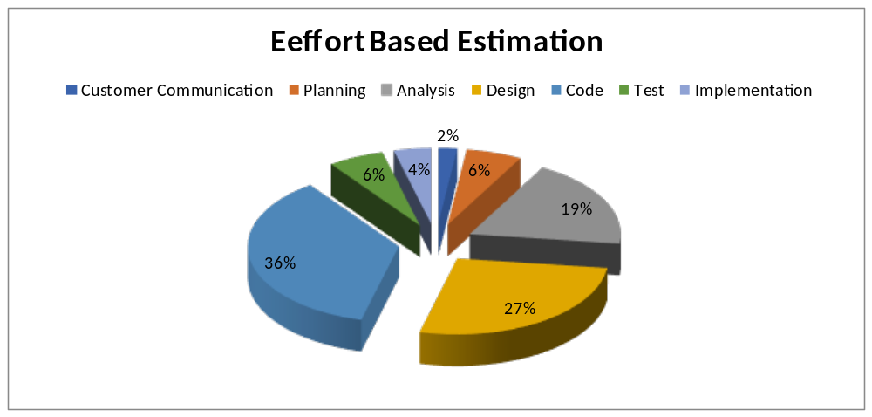
Figure 4.4: Effort Based Estimation

4.8 Project Schedule Chart
Total system development is a combination of set of tasks. These set of tasks should done sequentially and timely. Project schedule works as the guideline of the system developer. The following is the schedule chart of this project:

Category | 1st Month | 2nd Month | 3rd Month | 4th Month
Customer Communicator
Planning

Analysis

Design

Coding

Testing

Implementation

Figure 4.5: Project Schedule Chart
4.9 Cost Estimation

- Software Cost
- Hardware Cost
- Personnel Cost
- Other Cost

Software Cost:
Name | Amount
Windows 10 | 50.00
MS Office 2013 | 50.00
XAMPP | Free
MySQL | Free
Subline Text Editor | Free
Adobe Photoshop | 50.00
Total | 150

It is expected that the life of hardware is 5 years. So, an asset with a life of 5 would have a sum
of digits as follows: 5+ 4+ 3 +2 + 1 = 15.
The percentage of month is: 1/15 = 6.67% = 0.0667
The depreciation cost of Computer is = (30000 * 0.0667) = 200
The depreciation cost of Scanner is = (1800* 0.0667) = 120.06
The depreciation cost of Printer is = (2200* 0.0667) = 146.74

Hardware Cost:
Name | Amount | Depreciated Cost
Computer | 30000 | 200
Scanner | 1800 | 120.06
Printer | 2200 | 146.74
 | Total | 2267.8

Personnel Cost:
Type | Number | Month | Salary Per Month | Total
System Analyst | 1 | 2 | 12000 | 24000
Designer | 1 | 2 | 10000 | 20000
Code Developer | 1 | 2 | 8000 | 16000
Tester | 1 | 1 | 5000 | 5000
Total: |  |  |  | 65000

Other Cost:

Name/utility | Monthly Bill Rate | Bill calculated for 4 months
Electricity Bill | 800 | 3200
Internet Bill | 1000 | 4000
 | Total | 7200

Total System Development Cost:

Cost Type | Cost
Software Cost | 150 BDT.
Hardware Cost | 2,267.8 BDT.
Personnel Cost | 65,000 BDT.
Other Cost | 7,200 BDT.
Total | 74617.8 BDT.

Chapter 5
Analysis and Design

5.1 Activity Diagram:

5.1.1 Activity Diagram: Customer Registration

Customer gives basic info for registration

Invalid information
No
Correct info
Yes
Registration Successful

Display conformation massage
type

Figure 5.1: Activity Diagram: Add User

5.1.2 Activity Diagram: Activity Diagram: Login
Enter username, password

Correct
No

Yes
Access level define

Figure 5.2: Activity Diagram: Login

5.1.3 Activity Diagram: Delete User
Correct info

No
Admin enters user name/pass word

Invalid information

Yes
Delete user info
Display conformation massage

Figure 5.3: Activity Diagram: Delete User

5.1.4 Activity Diagram: Add products
Correct info

info
No
Admin enters user name/pass word

Invalid information

Yes
Products add
Display conformation massage

Figure 5.4: Activity Diagram: Add products
5.1.6 Activity Diagram: Update products
Correct info

info
No
Admin enters user name/pass word

Invalid information

Yes
Update products
Display conformation massage

Figure 5.5: Activity Diagram: Update products

5.1.7 Activity Diagram: Create Sales Order
Available

info
No
Customer choose product

Cart empty

Yes
Create Sales order
Display conformation massage

Figure 5.6: Activity Diagram: Create Sales Order

5.1.8 Activity Diagram: Update Sales Order
Correct info

info
No
Admin/User enters user name/pass word

Invalid information

Yes
Update Sales Order
Display conformation massage

Figure 5.7: Activity Diagram: Update Sales Order

5.1.9 Activity Diagram: Payment
Receive Order

Send Invoice

Receive payment

Receive payment

Figure 5.8: Activity Diagram for Payment
  - Class Diagrams
Class diagrams are the backbone of almost every object-oriented method including UML. They describe the static structure of a system.

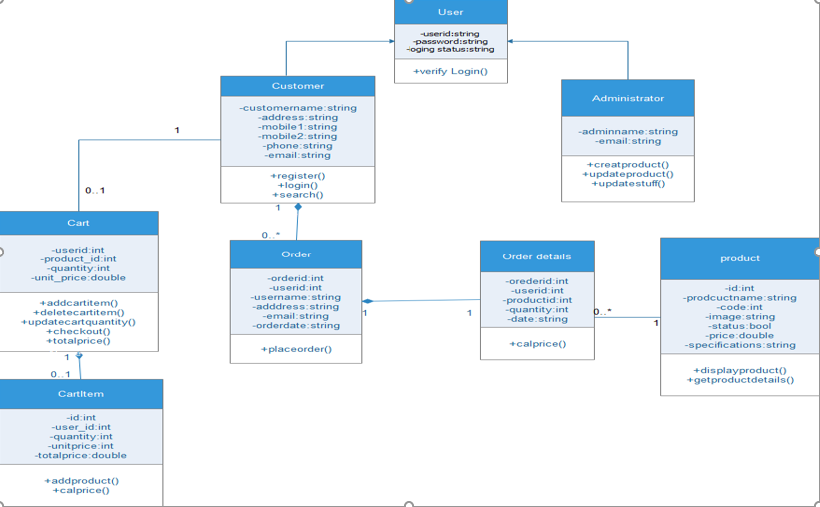
Figure 5.9: Class Diagrams

    - Class Descriptions

- User
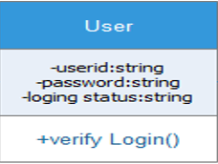

This class handles all user actions. The User class is the super class of Customer and Administrator. It includes the private methods to verify the login of the user. The verifyLogin() method is called when the user clicks the "Sign In" button. It returns true if the login is successful, false if it is not.

- Administrator

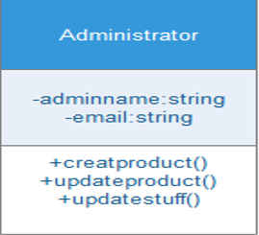

This class handles the Administrator actions. It inherits all the User class responsibilities and its functions. It has a functions createproduct(), update product(), update stuff() are called when the administrator has to create/add a new department or category or product respectively to the catalog.

Conditions for createProduct Operation

- Purpose: To enable Administrator to create and add new products to the catalog.
- Pre Condition: Administrator must be logged in to be able to create a new product. Also, the department and/or category to which the new new product is to be associated should exist in catalog.
- Post Condition: Product will be added to the corresponding department and/or category.
- Input: Administrator will enter the name and necessary details to create a new product and click "Add" button to complete the action.
- Output: After the action, the changes to the catalog will be updated and saved and a message will be displayed accordingly.

- Customer

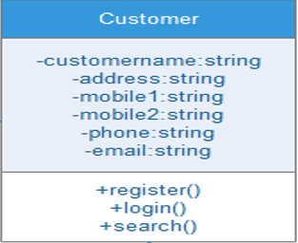

This class handles the customer actions. It inherits all the User class responsibilities and its functions. customer must register and login through the Register and Login Webpage which uses the register() and login() methods. Also, the search() function is called when customer searches for some product and enters some Key-Words in the text-box on Search page.

Conditions for Login Operation

- Purpose: This is implemented to enable user authentication. A valid user account must be used for an existing customer.
- Pre Condition: The customer should be registered with website and should have a valid userid and password.
- Post Condition: Customer will be able to browse through the website.
- Input: The customer can login to the e-Commerce shopping system by entering his user name and password.

- Output: The system will verify that the login name matches the login password. If the user name or password is invalid, the appropriate error message will be indicated and the user will be requested to re-enter user name and password. If the user inputs are valid, the main page will be displayed.

- Product

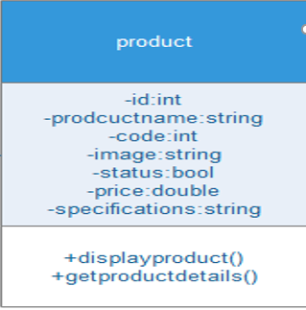

This class represents collection of products of a particular category and/or department. The displayProduct() and getProductDetails() method are called when the user clicks on a product or on the "Search" button on the Search. Web form. The displayProduct()

method is used to retrive image of the product and getProductDetails() method retrives its details as a data set whenever a customer clicks on the product. A product can belong to one or more departments and/or categories.

- ShoppingCart

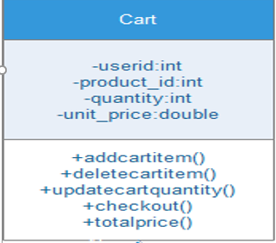

ShoppingCart class has all the products that are added by a customer to buy. The addCartItem() and deleteCartItem() methods are called when customer performs actions like "Add to Cart" and "Delete" of products on the ShoppingCart. Webpage. The updatequantity() method is called when Customer clicks "Update" button on ShoppingCart. Webpage to increase or decrease the number of products in the cart. Also, viewCartDetails() method is called when customer clicks on the "View Details" button to see a summary of the cart. It will display the summary only when cart is not empty, else it will display "Your Cart is empty."

Conditions for addCartItem Operation

- Purpose: This is implemented so the customer can add products to shopping cart while searching or browsing catalog.
- Pre Condition: The customer must be logged in to add a product to the cart.
- Post Condition: Product will be added to the shopping cart.
- Input: When customer finds the products he wants, he adds them to the shopping cart by clicking on the "Add to Cart" button.
- Output: Product will be added to the shopping cart and the system will store and keep track of the information of products that have been added into shopping cart.

Conditions for Checkout Operation

- Purpose: To allow customer to buy the products added to the shopping cart.
- Pre Condition: Customer must be logged in and must have atleast one item in shopping Cart to be able to checkout and place the order.
- Post Condition: Customer will be succesfully checked out and will be able to edit his profile information and place order.
- Input: When the customer finishes shopping, he requests to checkout by clicking "checkout" button on Cart. page.
- Output: If the payment information of this customer already exists, the system prompts the customer to review or input a new one. If the credit card is valid, the order form will be processed by the system and checkout is complete.

- Orders

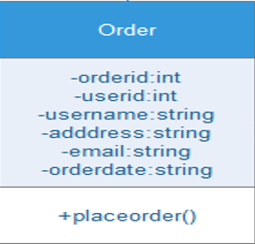

This class will store all information regarding the orders made by each customer. The placeOrder() method is called when customer clicks on the "Place Order" button on the Order Web form. It returns true if the order is placed successfully, false if it is not. The "Place Order" button will be enabled only when customer has a valid shopping cart and has entered valid personal, billing and shipping details.
Conditions for placeOrder Operation

- Purpose: To allow customer to place an Order for buying the products added to the shopping cart.
- Pre Condition: Customer must be logged in and must have atleast one item in shopping Cart to be able to place the order Also, customer should have correct profile information and valid Credit Card details entered into the system.
- Post Condition: Customer will be succesfully able to place the order.
- Input: When the customer finishes shopping, he requests to place an order by clicking "Place Order" button on Order page.
- Output: If the profile information, payment information the credit card of this customer is valid, the order form will be processed by the system and order is placed.

- OrderDetail

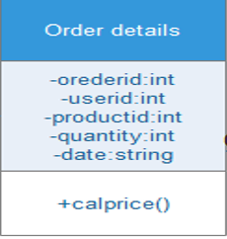

This Class handles details regarding every order that the customer makes. The calcPrice() method is called to calculate the total amount of the order placed. The method also calculates the total amount of the order including the shipping charges once the customer has selected the shipping region.

- CartItem

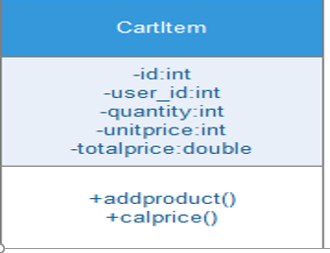

A CartItem object indicates the quantity, unitcost, subtotal amount of the product selected by a customer. When a customer performs a product selection and clicks "Add to Cart" button, a new cartItem object is created and added to the cart. The calcPrice() method is called to calculate the total amount of the items added to cart.

  - Entity Relationship Diagram(ERD)

An entity-relationship diagram (ERD) is a data modeling technique that graphically illustrates an information system’s entities and the relationships between those entities. An ERD is a conceptual and representational model of data used to represent the entity framework infrastructure.

The elements of an ERD are:
- Entities
- Relationships
- Attributes
Steps involved in creating an ERD include:
- Identifying and defining the entities
- Determining all interactions between the entities
- Analyzing the nature of interactions/determining the cardinality of the relationships
- Creating the ERD

Entity
Entities are represented by means of rectangles. Rectangles are named with the entity set they represent.

An entity represented by a rectangle.
Attributes
Attributes are properties of entities. Attributes are represented by means of eclipses. Every eclipse represents one attribute and is directly connected to its entity (rectangle).

A relationship described by aneclipse.

Relationship
Relationships are represented by diamond shaped box. Name of the relationship is written in the diamond-box. All entities (rectangles), participating in relationship, are connected to it by a line.

A relationship described by a diamond.

BINARY RELATIONSHIP AND CARDINALITY
A relationship where two entities are participating, is called a binary relationship. Cardinality is the number of instance of an entity from a relation that can be associated with the relation
One-to-one
When only one instance of entity is associated with the relationship, it is marked as '1'. This image below reflects that only 1 instance of each entity should be associated with the relationship. It depicts one-to-one relationship

One-to-many
When more than one instance of entity is associated with the relationship, it is marked as 'N'. This image below reflects that only 1 instance of entity on the left and more than one instance of entity on the right can be associated with the relationship. It depicts one-to-many relationship


Many-to-one
When more than one instance of entity is associated with the relationship, it is marked as 'N'. This image below reflects that more than one instance of entity on the left and only one instance of entity on the right can be associated with the relationship. It depicts many-to-one relationship.
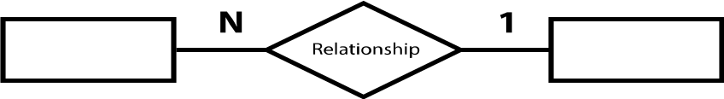

Many-to-many
This image below reflects that more than one instance of entity on the left and more than one instance of entity on the right can be associated with the relationship. It depicts many-to-many relationship
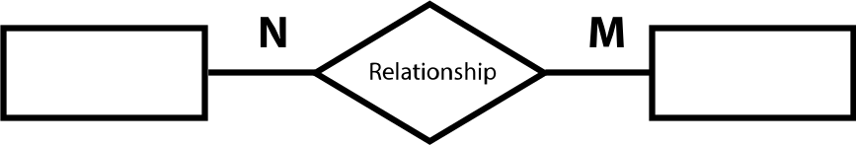
PARTICIPATION CONSTRAINTS
Total Participation: Each entity in the entity is involved in the relationship. Total participation is represented by double lines.
Partial participation: Not all entities are involved in the relationship. Partial participation is represented by single line.
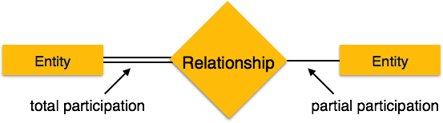
Primary Key: A primary key is an attribute or collection of attributes that allow us to identify an entity uniquely.
Foreign key: A foreign key is an attribute of a relation, which refers to an existing attribute of another relationship.

ER Diagram

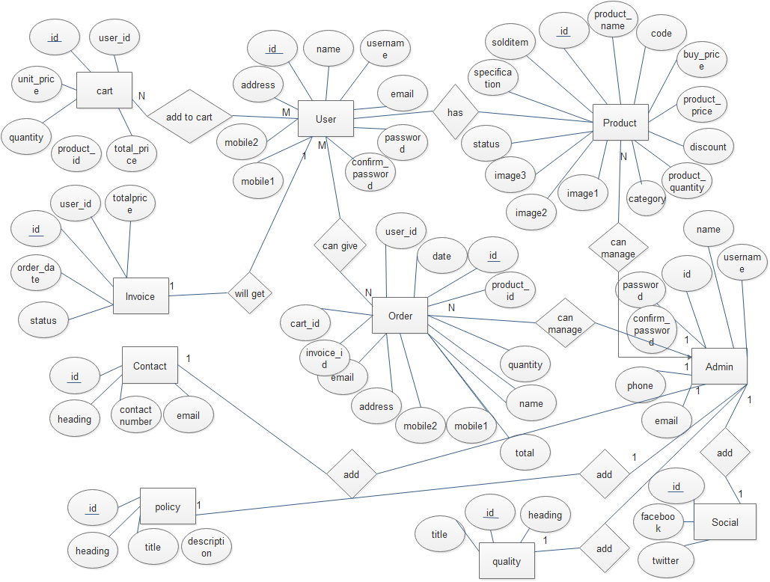
Figure 5.10: Entry Relationship Diagram

5.4 Data Flow Diagram

A data flow diagram is a graphical representation that depicts information flow and the transforms that are applied as data move from input to output.

The DFD may use to represent a system or software at any level of abstraction. DFD may partition into levels that represent increasing information flow and functional detail. Therefore, the DFD provides a mechanism for functional modeling as well as information flow modeling.

A level 0 DFD, which is also known as fundamental system model or a context model, represents the entire software or system element into as a single bubble with input and output data indicated by incoming and outgoing arrows respectively. Then bubble of context model should decompose into several levels.

Data Flow Diagram of E-Commerce System:
Context Level Diagram
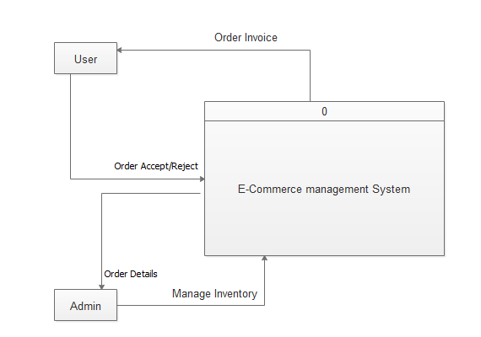
Figure: 5.11: Context Level Diagrams
Level 1 Diagram:
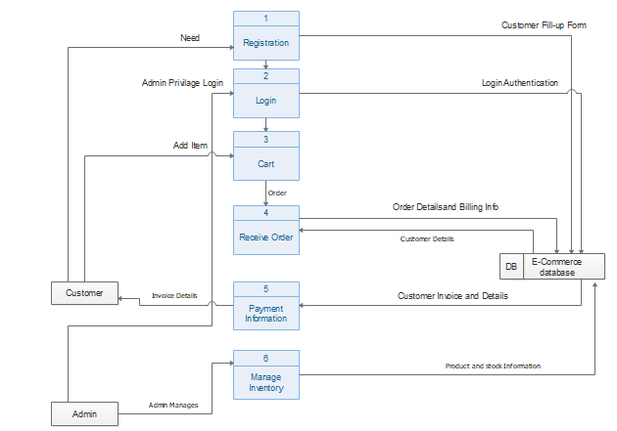
Figure 5.12: Level 1 Diagrams

Level 2 Process 1 Diagram (Registration):
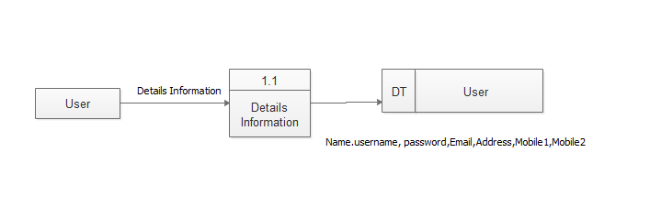
Figure 5.13: Level 2 of Process 1 Diagrams

Level 2 Process 2 Diagrams (Login):
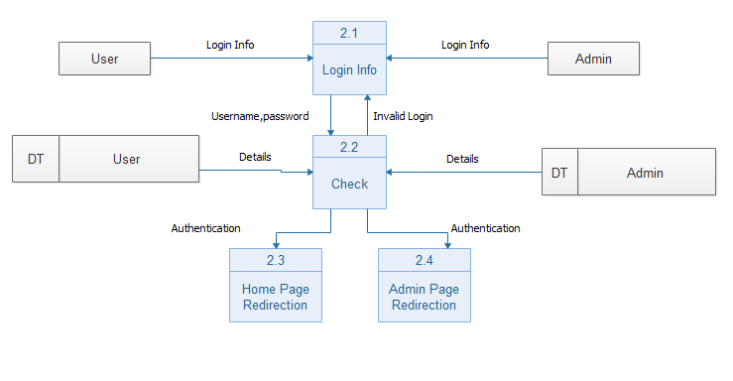
Figure 5.14: Level 2 of Process 2 Diagrams

Level 2 Process 3 Diagrams(Cart):
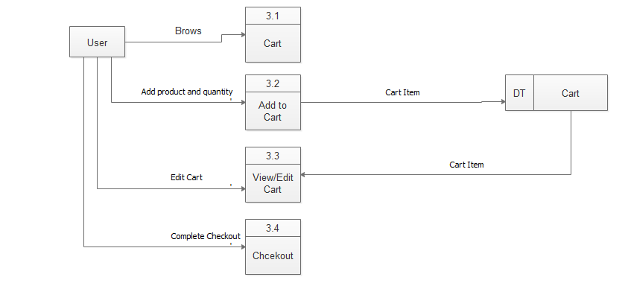
Figure 5.16: Level 2 of Process 3 Diagrams

Level 2 Process 4 Diagrams(Order):
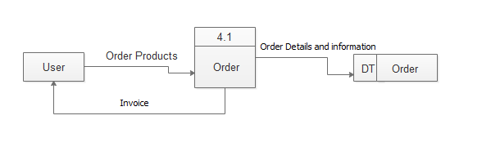
Figure 5.17: Level 2 of Process 4 Diagrams

Level 2 Process 5 Diagrams(Payment):
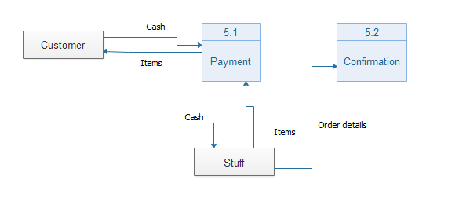
Figure 5.18: Level 2 of Process 5 Diagrams

Level 2 Process 6 Diagrams (Stock):
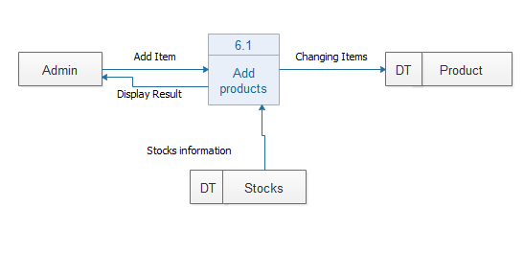
Figure 5.19: Level 2 of Process 6 Diagrams

Chapter 6
Risk Engineering

  - Risk Engineering

Risk analysis and management are a series of works that help a system development team to understand and manage uncertainty. Many problems can arise while developing a system. A risk is a potential problem – it may happen may not. There are several steps to analyze and manage risks. The first step is risk identification. Next each risk is analyzed to determine the likelihood that it will occur and the damage that it will do if it does occur. Once this information is established risks are remarked. Finally, a plan is developed to manage those risks with high probability and impact.

There are different Stages of risks. They area:
- Risk identification: Risk identification is the process of detecting potential risks or hazards through data collection. A range of data collection and manipulation tools and techniques exists. The team is using both automated and manual techniques to collect data and begin to characterize potential risks to Web resources. Web crawling is one effective way to collect information about the state of Web pages and sites.
- Risk classification: Risk classification is the process of developing a structured model to categorize risk and fitting observable risk attributes and events into the model. The team combines quantitative and qualitative methods to characterize.
- Risk assessment: Risk assessment is the process of defining relevant risk scenarios or sequences of events that could result in damage or loss and the probability of these events. Many sources focus on risk assessment. Rosenthal describes the characteristics of a generic standard for risk assessment as "transparent, coherent, consistent, complete, comprehensive, impartial, uniform, balanced, defensible, sustainable, flexible, and accompanied by suitable and sufficient guidance.
- Risk analysis: Risk analysis determines the potential impact of risk patterns or scenarios, the possible extent of loss, and the direct and indirect costs of recovery. This step identifies vulnerabilities, considers the willingness of the organization to accept risk given potential consequences, and develops mitigation responses.
- Risk management implementation: defines policies, procedures, and mechanisms to manage and respond to identifiable risks. The implemented program should balance the value of assets and the direct and indirect costs of preventing or recovering from damage or loss.

  - Risk Identifications

Risk Type | Possible Risks
Technology | - Security of the system.  - Reusable software components may contain defects and cannot be reused as planned.
People | - Key staff are ill and unavailable at critical  - times.  - Required training for staff is not available.
Organization | - Organizational financial problems reductions in the project budget.
Requirements | - Changes to requirements that require major  design rework are proposed.  - Customers fail to understand the impact of  requirements changes.

  - Risk Analysis
Risk | Probability | Effect
Organizational financial problems force reduction in the project budget | Low | Disastrous
Security of the System High Serious | High | Serious
Reusable software components contain defects that means they cannot be reused as planned. | Moderate | Serious
Changes to requirements that require major design rework are proposed. | Moderate | Serious
Required training for staff is not available. | Moderate | Tolerable
Customers fail to understand the impact of requirements changes. | Moderate | Tolerable

  - Risk Planning
Risk | Strategy
Security | Investigate the possible security leaks and measurements.
Organizational financial  problem | Prepare a briefing document for senior management showing how the project is making a very important contribution to the goals of business and presenting reasons why cuts to the project budget would not be cost-effective.
Requirements problems | Alerts customer to potential difficulties and possibilities of delay, investigate buying in components
Staff illness | Reorganize them so that there is more overlap work and people therefore understand each other jobs.
Defective component | Replace defective potential components with bought in component of know reliability.
Requirements change | Replace defective potential component with bough in component of know reliability.
Requirement changes | Derive traceability information to access requirements, change impact, maximizing information hiding in the design.

  - Risk Monitoring
A re-planning of the project occurs. New task schedule and milestones are defined. Staffs work
on their assigned jobs within the new timelines. In order to prevent this happening, the software
will develop for the end user.
The user interface will design in a way to make of the program convenient and pleasurable.
Meetings (formal and informal) will be the client regularly. This ensures that the software we are
developing solves problems.
The development cost of the software may increase by 20%. During development it is advised to
consult with the system analyst during the system analysis, design testing phase of the software
project.
Proper coding grammar is followed to make sure that the codes are easily understandable and
reusable.
Cost and time will increase and project will be updated. Everything will be at where it all started.

Chapter 7
System Assurance & Testing

7.1 Software Quality Assurance
Software quality assurance is a planned and systematic pattern of all actions necessary to provide adequate confidence that an item or product conforms to established technical requirements and a set of activities designed to evaluate the process by which the products are developed or manufactured. Contrast with: quality control.
A systematic, planned set of actions necessary to provide adequate confidence that the software development process or maintenance process of a software system product conforms to established functional technical requirements.
The quality of software is assessed by a number of variables. These variables can be divided into external and internal quality criteria. External quality is what a user experiences when running the software in its operational mode. Internal quality refers to aspects that are code-dependent, and that are not visible to the end-user. External quality is critical to the user, while internal quality is meaningful to the developer only.
External Quality (Functional):
- Stability
- Speed
- Accuracy
- Features
- Robustness
- Ease-of-use
Internal Qualities (Structural):
- Maintainability
- Flexibility
- Re-usability
- Readability
- Understandability

7.2 Software Quality Management Process
Software quality management (SQM) is a management process that aims to develop and manage the quality of software in such a way so as the best ensure the product meets the quality standards expected by the customer while also meeting any necessary regulatory and developer requirements, if any. Software quality managers require software to be tested before it is released to the market, and they do this using a cyclical process-based quality assessment in order to reveal and fix bugs before release. The job is not only to ensure their software is in good shape for the consumer but also to encourage a culture of quality throughout the enterprise.
Some of the specific SQM processes are defined below in standard:

7.2.1 Quality Assurance Process
Quality Assurance makes sure the project will be completed based on the previously agreed specifications, standards and functionality required without defects and possible problems. Its monitors and tries to improve the development process from the beginning of the project to ensure this.
7.2.2 Verification & Validation (v&v) Process
Verification and validation – These are the two important aspects of software quality management. Verification gives the answer to the question whether the software is being developed in a correct way and validation provides the answer whether the right software is being produced. In a nutshell, verification denotes precision whereas validation indicates value of the end or final product or software. Verification and validation is an important step used in various processes in different industries.
7.2.3 Review Process
The purpose of a technical review is to evaluate a software product to determine its suitability for its intended use. The objective is to identify discrepancies from approved specifications and standards. The results should provide management with evidence confirming (or not) that the product meets the specifications and adheres to standards and that changes are controlled.
7.2.4 Audit Process
The purpose of a technical review is to evaluate a software product to determine its suitability for its intended use. The objective is to identify discrepancies from approved specifications and standards. The results should provide management with evidence confirming (or not) that the product meets the specifications and adheres to standards and that changes are controlled. procedures. The audit is a formally organized activity, with participants having specific roles, such as lead auditor, another auditor, a recorder, or an initiator, and includes a representative of the audited organization. The audit will identify instances of nonconformance and produce a report requiring the team to take corrective action.
7.3 Testing

Testing scenario No:1
Scenario | Admin Login testing scenario of this system
Input’s | Username, password of admin for Login
Desired Output’s | When enter username, password then get successful level define.
Actual Output’s | For login our system work correctly
Verdict | Getting result from Desired Output’s and Actual Output’s decided this system is successful for login.

Testing scenario No:2
Scenario | Admin can add Products
Input’s | Products Information
Desired Output’s | When enter all basic info correctly, Products will be registered in the system.
Actual Output’s | For adding products our system work correctly
Verdict | Getting result from Desired Output’s and Actual Output’s decided this system is successful for Adding Products.

Testing scenario No:3
Scenario | Admin can add Stuffs
Input’s | Giving Stuff’s basic info correctly
Desired Output’s | When enter all the basic info stuff will be registered
Actual Output’s | For adding Stuffs our system work correctly
Verdict | Getting result from Desired Output’s and Actual Output’s decided this system is successful for Adding stuffs

Testing scenario No:4
Scenario | Admin can add Layouts.
Input’s | Layouts Basic inputs
Desired Output’s | When enter all basic info correctly, System Layouts will be registered
Actual Output’s | For Adding layouts our system work correctly
Verdict | Getting result from Desired Output’s and Actual Output’s decided this system is successful for adding layouts

Testing scenario No:5
Scenario | Admin can edit Products.
Input’s | Products basic info update by the admin
Desired Output’s | When changed basic information for the Product by the admin.
Actual Output’s | For update Product info our system work correctly
Verdict | Getting result from Desired Output’s and Actual Output’s decided this system is successful for update Product details.

Testing scenario No:6
Scenario | Admin can remove Stuffs
Input’s | Delete Stuffs from our database.
Desired Output’s | When admin want he/she can remove an Stuffs
Actual Output’s | I check this process and get actual outputs
Verdict | The process is worked correctly and successfully.

Testing scenario No:7
Scenario | Take daily monthly reports and calculate profit.
Input’s | Admin give whole month all cost and incomes.
Desired Output’s | Systems take the information and calculate monthly profit and print the profit.
Actual Output’s | I check this process and get actual outputs
Verdict | The process is worked correctly and successfully.

Testing scenario No:8
Scenario | System adds products in stock product.
Input’s | Manager add medicine with all information.
Desired Output’s | System takes all information display the product in stocks.
Actual Output’s | I check this process and get actual outputs
Verdict | The process is worked correctly and successfully.

Chapter 8
Conclusion

8.1 Conclusion

In four years’ study of undergraduate program of IUBAT, what I have learnt from honorable, beloved teachers and supportive educational environment, I tried my best to implement those knowledge during my internship period. Since this project has been designed exclusively as an internship project, certain complexities those faced by any real life problem are considered in this project. But enhancement to the project can easily be made without changing the current design and programming structure

References

[1] itemis.com, (n.d.). Agile Process Models. [Online] Available at:
https://www.itemis.com/en/agile/scrum/compact/fundamentals-of-project-management/Rad process-models [Accessed 26 October. 2017].

[2] softwaremetrics.com, (n.d.). Fundamentals of FPA. [Online] Available at:
http://www.softwaremetrics.com/fpafund.htm [Accessed 29 October. 2017].

[3] bcarocks.com, (2013). Effort Distribution. [Online] Available at:
http://www.bcarocks.com/notes/sem3-notes/software-engineering-notes/effort-distribution.html
[Accessed 30 October. 2017]

[4] wikipedia.org, (2017). Activity diagram. [Online] Available at:
https://en.wikipedia.org/wiki/Activity_diagram [Accessed 3 November. 2017]

[5] visual-paradigm.com, (n.d.). What is Data Flow Diagram?. [Online] Available at:
https://www.visual-paradigm.com/guide/data-flow-diagram/what-is-data-flow-diagram/ [Accessed 5 November. 2017]

Bibliography

[1] Pressman, Roger S. Software Engineering: A Practitioner’s Approach. 5th ed. Boston: McGraw Hill, 2004.

[2] Kendall, E. Kendall. System Analysis and Design.7th New Delhi: Prentice Hall.

